Creative Questioning in the Classroom

Why is questioning important?

It helps to:

extend thinking skills

clarify understanding

gain feedback on teaching / learning

provide revision strategies

create links between ideas

enhance curiosity

provide challenges

strengthen learning

Good questions are:

purposeful ( asked to achieve a specific purpose)

clear ( students understand what they mean)

brief ( stated in as few words as possible)

natural ( stated simply, in conversational English)

thought-provoking ( they stimulate thoughts and responses)

limited in scope ( only one or two points in chain of reasoning called for)

adapted to the level of the class ( tailored to the kinds of students in the class.)

Questioning will be most effective when questions are:

planned

logical and sequential

addressed to the entire class

posed so students have time to think

balanced between facts and thoughts

distributed widely

not repeated, paraphrase if necessary

asked in conversational tone
- put into consideration the different levels
- suit the different learning styles and the multiple intelligences

Techniques for Effective Classroom Questions:
- Questions covering key points should be carefully prepared in advance and should follow an order which
gradually develops the topic.
- Use questions to help students connect important concepts.
- Ask questions from all levels of Bloom's Taxonomy of Educational Objectives .
- Minimize the use of "yes / no" questions except when checking meaning and understanding or encouraging
weaker students.
- Ask questions about important points rather than trivial content.
- Grade language in questions and try not to over-paraphrase.
- Personalize questions where possible.
- Put the question to the whole class.
- Spread questions randomly around the class.
- Nominate one student to answer the question. (Never pre-nominate)
- Do not call upon the students to answer in any regular order. Scatter the questions around the class.
- Ensure that everyone gets a fair share of questions. This will ensure the attention of the whole class.
- Direct the questions around the class in a manner which will ensure that all students feel they are contributing to
the lesson development.

Responding Effectively

- Require good, clear answers from the students. Make them speak up so the whole class can hear.
- Wait for students to think and formulate responses.
Waiting 5-10 seconds will increase the number of students who volunteer to answer and will lead to longer, more complex answers. If students do not volunteer before 5 seconds have passed, refrain from answering your own question, which will only communicate to students that if they do not answer, you will do their thinking for them. If the students are unable to answer after sufficient time for thinking has passed, rephrase the question.
- Listen carefully to students' responses to questions.
- Regard every answer that is given with importance and respect.
- Show that you are interested in students’ answers, whether right or wrong.
Encourage students when they are offering answers by nodding, looking at them, and using facial expressions that show you are listening and engaged. Do not look down at your notes while they are speaking.
- Do not accept inexact, careless or incomplete answers and do not fill in the gaps for the student to save time.

- Praise the students who give correct answers accordingly; don’t over react.
- If a student gives an incorrect or weak answer, point out what is incorrect or weak about the answer, but ask the student a follow-up question that will lead that student, and the class, to the correct or stronger answer.
- Do not interrupt students’ answers.
You may find yourself wanting to interrupt because you think you know what the student is going to say, or simply because you are passionate about the material. Resist this temptation. Hearing the students’ full responses will allow you to give them credit for their ideas and to determine when they have not yet understood the material.
- Do not repeat all of the answers given by the students. However, on occasion, especially when a vital point has been made or confirmed by a student, repeating his answer can constitute a very useful and important reinforcement for the rest of the class.
- Develop responses that keep students thinking.
For example, ask the rest of the class to respond to an idea that one student has just presented, or ask the student who answered to explain the thinking that led to her answer.
- Ask other students to paraphrase what has been said. This improves attentiveness and measures comprehension, as well as fosters discussion.
- Provide multiple and varied opportunities for interaction among students around ideas.
- Recognize every answer as an opportunity to assess understanding.
- KEEP THE PACE LIVELY!

Types of Questions

According to … |  | What they are for/ they mean … | Example
when they are asked | At the beginning | For: Revising the previous lessons  Rising the students’ interest  Introducing the new lesson | 1st Intermediate, unit 9 clothes, lesson 2:  Show the students a picture of a girl and ask:  What is she wearing? What colour is it?
when they are asked | In the middle | For: Focusing on the main information and skills  Diagnosing the students’ strengths & weaknesses  Encouraging the students’ participation | Ask questions about the same picture:  What is her blouse like?  How much is her watch? ….etc.
when they are asked | At the end | For: linking the different parts of the lesson  Getting feedback  Assessing the students | Ask the students to:  Describe their bags: colour, size, price …  Complete a conversation
the answers expected | Open & closed | An open question elicits longer answers. It asks the respondent for her knowledge, opinion or feelings. | Tell me what happened.  Why did he react that way?
the answers expected | Open & closed | A closed question usually receives a single word or a very short factual answer. | Are you thirsty?  Where do you live?
the answers expected | Convergent  & Divergent | A convergent question is a question that there is a single or accepted "correct" answer to it. | Instructor: "According to our textbook, in what ways does the present welfare system solve the problems of poverty?"
the answers expected | Convergent  & Divergent | A divergent question is a question that there are a number of possible answers, many of which may be acceptable. | Instructor: "What are some ways in which the country might solve the problems of poverty?"
the purpose | Leading | These questions try to lead the respondent to your way of thinking or give you the response you want. This can done in several ways: | * With an assumption: “How late do you think that the project will deliver?”  *Phrasing the question so that the “easiest” response is “yes”: shall we continue?  * Giving people a choice between two options, both of which you would be happy with
the purpose | Probing | It is a strategy for finding out more detail.  We ask them when we need additional information for clarification. | Gaining clarification, explanation or justifying :  What exactly do you mean by …..?  Why do you think the prisoner helped Pip?
the purpose | Funnel | It involves starting with general questions, and then homing in on a point in each answer, asking more detail. | How many people were involved in the fight?  What sort of ages were they?  Where they wearing anything special?
the purpose | Rhetorical | Rhetorical questions aren’t really questions at all. They don’t expect an answer. They’re just statements phrased in question form to ease the listeners’ feeling that they are being “told” something. | “Isn’t John’s design work so creative?”
the level of thinking | Knowledge | Identification and recall of information | Can you name the sources of …?
the level of thinking | Comprehension | Organization and selection of facts and ideas | Retell (in your own words).
the level of thinking | Application | Use of facts, rules, principles | From the information given, can you develop a set of instructions about ….?
the level of thinking | Analysis | Separation of a whole into component parts | How does … compare/contrast with…?
the level of thinking | Synthesis | Combination of ideas to form a new whole | Can you create a new uses for …?
the level of thinking | Evaluation | Development of opinions, judgments or decisions | Judge the value of ……?

Bloom's Taxonomy

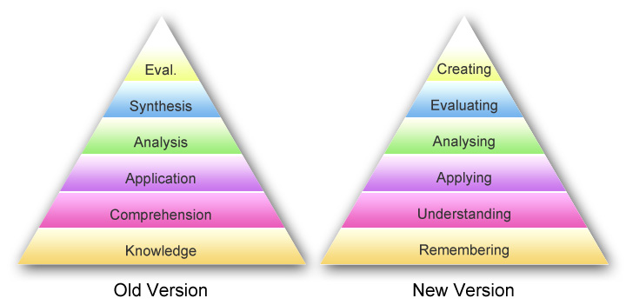

Using the Revised Taxonomy in an adaptation from the Omaha Public Schools Teacher's Corner, a lesson objective based upon the story of Goldilocks and the Three Bears is presented for each of the six levels of the Cognitive Process as shown on the Revised Taxonomy Table.
Remember: Describe where Goldilocks lived.
Understand: Summarize what the Goldilocks story was about.
Apply: Construct a theory as to why Goldilocks went into the house.
Analyze: Differentiate between how Goldilocks reacted and how you would react in each story event.
Evaluate: Assess whether or not you think this really happened to Goldilocks.
Create: Compose a song, skit, poem, or rap to convey the Goldilocks story in a new form.
Although this is a very simple example of the application of Bloom's taxonomy the author is hopeful that it will demonstrate both the ease and the usefulness of the Revised Taxonomy Table.

Bloom's Taxonomy
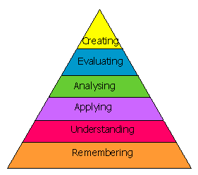

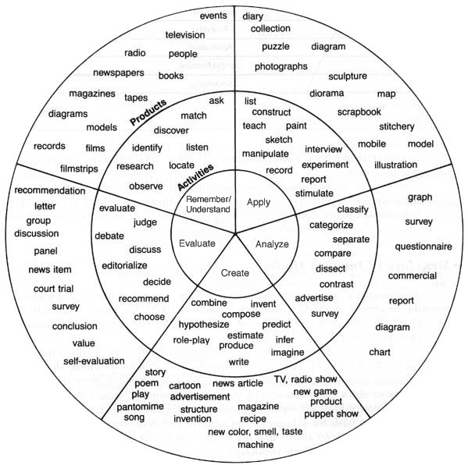

A

Applying Bloom's Taxonomy in Questions

As teachers we tend to ask questions in the "knowledge" category 80% to 90% of the time. These questions are not bad, but using them all the time is. Try to utilize higher order level of questions. These questions require much more "brain power" and a more extensive and elaborate answer. Below are the six question categories as defined by Bloom.
Knowledge | Useful Verbs | Sample Question Stems | Potential activities and products
Knowledge | tell  list  describe  relate  locate  write  find  state  name | What happened after...?  How many...?  Who was it that...?  Can you name the...?  Describe what happened at...?  Who spoke to...?  Can you tell why...?  Find the meaning of...?  What is...?  Which is true or false...? | Make a list of the main events..  Make a timeline of events.  Make a facts chart.  Write a list of any pieces of information you can remember.  List all the .... in the story.  Make a chart showing...  Make an acrostic.  Recite a poem.

Comprehension | Useful Verbs | Sample Question Stems | Potential activities and products
Comprehension | explain  interpret  outline  discuss  distinguish  predict  restate  translate  compare  describe | Can you write in your own words...?  Can you write a brief outline...?  What do you think could of happened next...?  Who do you think...?  What was the main idea...?  Who was the key character...?  Can you distinguish between...?  What differences exist between...?  Can you provide an example of what you mean...?  Can you provide a definition for...? | Cut out or draw pictures to show a particular event.  Illustrate what you think the main idea was.  Make a cartoon strip showing the sequence of events.  Write and perform a play based on the story.  Retell the story in your words.  Paint a picture of some aspect you like.  Write a summary report of an event.  Prepare a flow chart to illustrate the sequence of events.  Make a colouring book.

Application | Useful Verbs | Sample Question Stems | Potential activities and products
Application | solve  show  use  illustrate  construct  complete  examine  classify | Do you know another instance where...?  Could this have happened in...?  Can you group by characteristics such as...?  What factors would you change if...?  Can you apply the method used to some experience of your own...?  What questions would you ask of...?  From the information given, can you develop a set of instructions about...?  Would this information be useful if you had a ...? | Construct a model to demonstrate how it will work.  Make a diorama to illustrate an important event.  Make a scrapbook about the areas of study.  Make a paper-mache map to include relevant information about an event.  Take a collection of photographs to demonstrate a particular point.  Make up a puzzle game suing the ideas from the study area.  Make a clay model of an item in the material.  Design a market strategy for your product using a known strategy as a model.  Dress a doll in national costume.  Paint a mural using the same materials.  Write a textbook about... for others.

Analysis | Useful Verbs | Sample Question Stems | Potential activities and products
Analysis | analyze  distinguish  examine  compare  contrast  investigate  categorize  identify  explain  separate  advertise | Which events could have happened...?  I ... happened, what might the ending have been?  How was this similar to...?  What was the underlying theme of...?  What do you see as other possible outcomes?  Why did ... changes occur?  Can you compare your ... with that presented in...?  Can you explain what must have happened when...?  How is ... similar to ...?  What are some of the problems of...?  Can you distinguish between...?  What were some of the motives behind...?  What was the turning point in the game?  What was the problem with...? | Design a questionnaire to gather information.  Write a commercial to sell a new product.  Conduct an investigation to produce information to support a view.  Make a flow chart to show the critical stages.  Construct a graph to illustrate selected information.  Make a jigsaw puzzle.  Make a family tree showing relationships.  Put on a play about the study area.  Write a biography of the study person.  Prepare a report about the area of study.  Arrange a party. Make all the arrangements and record the steps needed.  Review a work of art in terms of form, colour and texture.

Synthesis | Useful Verbs | Sample Question Stems | Potential activities and products
Synthesis | create  invent  compose  predict  plan  construct  design  imagine  propose  devise  formulate | Can you design a ... to ...?  Why not compose a song about...?  Can you see a possible solution to...?  If you had access to all resources how would you deal with...?  Why don't you devise your own way to deal with...?  What would happen if...?  How many ways can you...?  Can you create new and unusual uses for...?  Can you write a new recipe for a tasty dish?  can you develop a proposal which would... | Invent a machine to do a specific task.  Design a building to house your study.  Create a new product. Give it a name and plan a marketing campaign.  Write about your feelings in relation to...  Write a TV show, play, puppet show, role play, song or pantomime about...?  Design a record, book, or magazine cover for?  Make up a new language code and write material suing it.  Sell an idea.  Devise a way to...  Compose a rhythm or put new words to a known melody.

Evaluation | Useful Verbs | Sample Question Stems | Potential activities and products
Evaluation | judge  select  choose  decide  justify  debate  verify  argue  recommend  assess  discuss  rate  prioritise | Is there a better solution to...  Judge the value of...  Can you defend your position about...?  Do you think ... is a good or a bad thing?  How would you have handled...?  What changes to ... would you recommend?  Do you believe?  Are you a ... person?  How would you feel if...?  How effective are...?  What do you think about...? | Prepare a list of criteria to judge a ... show. Indicate priority and ratings.  Conduct a debate about an issue of special interest.  Make a booklet about 5 rules you see as important. Convince others.  Form a panel to discuss views, e.g. "Learning at School."  Write a letter to ... advising on changes needed at...  Write a half yearly report.  Prepare a case to present your view about...

STUDENTS’ QUESTIONS

Negative Pressure
There are a number of forces at work to discourage students from asking questions. A good teacher works constantly to overcome these negative forces.
The primary negative pressure against questions is "stupid" pressure. Students tend to feel stupid when asking questions. They especially feel stupid if the teacher answers questions in such a way that it makes them look like a fool in front of their peers. But "stupid" pressure is at work even when you are tutoring a student one-on-one, because nobody wants to admit that they don't know something: this is part of being human.
Many other forces work against questions. Large classes discourage dialog and questions because any intimacy or friendliness between students and teacher is discouraged by the sheer size of the class.
Questions are also discouraged by time pressure. You may need to get through a certain amount of material on a given day, and you therefore leave fewer gaps for questions.
Another pressure that frequently discourages questions is the attitude or personality of the teacher. If the teacher insults students who ask questions, or makes them feel foolish, or sends signals that questions waste time (e.g. - negative tone of voice, monosyllabic answers, saying "we don't have time for that question", etc.), then students will not ask questions, and the class will become a monologue.

Encouraging Questions
A teacher cannot encourage questions solely by standing at the front of the class and asking, "Are there any questions?" There is so much pressure forcing students NOT to ask questions that it cannot be overcome by this single act.
The only way to encourage questions is to create a complete "question-asking environment" in the classroom. You must encourage questions constantly, using a variety of techniques.
The most important technique that you can use to encourage questions is to always answer questions kindly.
Here are some other ways to promote questions:
- Make it easy for students to ask questions
- Make time for questions
- Wait for students to formulate questions
- Ask other students to answer
- Make students who ask questions feel like they have done you a favor by asking a question. Reward students for asking a question. Try saying, "That's a great question" for every new question you get.
- Leave gaps for questions that are long enough for students to actually formulate questions. Rustle through your notes or drop a pencil or erase the board - leave good sized gaps throughout your lectures.
- Do not insult students, even subtly, when answering a question. Would you like to be talked to in that way? Put yourself in your students' shoes. Also listen to the answers you give - do you answer the questions?
- Give appropriate responses to questions, particularly where correction is required. and in order to extend the dialogue.

A good question-asking environment is a fragile and delicate thing. It must be nurtured every day. Once a good environment is created however, it can make a significant contribution to the quality of your class.

Creative questioning for young learners:

Ask students to use their senses:

They may often have their creative talents stretched by asking them to use their senses in a creative way.

Ask students about changes: one way to help students to think more creatively is to ask them to change things to make them the way they would like

E.g. What would taste better if it were sweeter? What would be nicer if it were smaller?

Ask questions with lots of answers:

Any time you ask a student a question which requires a variety of answers , you are aiding creative thinking skills. Here are some examples of using the concept of water: - What floats in water? - How does water help us?

Ask “what would happen if ….” questions:

These questions are fun to ask and allow the children to really use their imaginations. Here are some:

- What would happen if all cars were gone? - What would happen if you could fly?

Ask “ In how many different ways ….” questions.

These questions also extend students’ creative thinking. - In how many different ways could an umbrella be used?

Questioning to Encourage Students Ask Questions

Students learn about questioning by practising questioning.

- Ask as Many Questions
In this activity, students come up with as many questions as they can to ask about a picture or a topic (water, oil, money, houses, fire, pollution).

Activity:
Each group has a picture, they have to write as many pictures as they can. The winner group is the one who wrote the biggest number of correct questions.

- Twenty Questions
One or more students choose a specific article, person or place. The rest of the class (group) are allowed 20 questions to which the answer must be ‘yes’ or ‘no’ in order to find the answer. They may at any time ask directly ‘Is it..?’ but if it is not the right guess, the ‘no’ answer is included in the 20 questions that they are allowed to make. One can only make 3 guesses. This kind of game offers greater opportunities for students to practice asking questions.
Example: ‘Is it someone?’ ‘No’
‘Is it an animal?’ ‘No’
‘Is it something that is found in the house?’ ‘No’ ……etc.

Activity:
In your group take turns to select a topic and play the game. Be prepared to demonstrate it in front of the whole group.

3. Hot Seating
One member of the group chooses a person from literature, history, current events and reveals their choice. The others’ task is to design questions to ask about the respondent’s knowledge, experience, …. etc.
Example: subject chooses Shakespeare.
Questions: 1. In what way did you change the world?
2. If you were alive today where would you like to be and with whom?
3. What things in your life do you regret?

Activity:
In your group, take turns to practise the game and be prepared to model the game to the larger group.

4. Answer/Question
In this activity, students come up with questions for answers. You could also have half the class with questions and the other half with answers and the students move around until they find the match. When found they sit down. The game continues until everyone is seated.
Example: plays & poems. Why is Earth unique?
to Arab & non-Arab countries. What did Shakespeare write?
because it is the only planet that has life. Who unified the Kingdom of Saudi Arabia?
King Abdul-Aziz Where does Arab Aid go?

Activity:
A body of a foreigner was found by a young man. Many people gathered to find out about this mysterious event. Some of their questions were ……………

5. Question/Question
Here the students are practising making questions by answering each question with a question. The rule is that you cannot repeat your partners question and the guideline is that each question should open up possibilities for your partner.
Example: A. Are we going together?
B. Do you want me to come with you?
A. Isn’t it necessary for both of us to go?
B. How much do we have to carry?
A. You don’t expect me to help surely?
B. Haven’t you forgotten that I have a bad back? (and so on….)

Activity:
Choose your own stem to start the process and see if you can keep the exercise going? Some stem starters:-
What shall we do this afternoon?
Why should we…?
What would happen if….?
Can you think of…?

