Full Blast1
1st Term Syllabus Distribution 1440^{H}/1441^{H} / 1st Grade Intermediate

Weeks |  |  |  |  |  |  | Months
4th week | 3rd week |  | 2nd week |  | 1st week |  |  | Moharram
23/1 – 27/1 | 16/1 – 20/1 |  | 9/1 – 13/1 |  | 2/1 – 6/1
Module 1  1c+1d | Module 1  Who are you?  1a +1b |  | Hello |  | Back to School
8th week | 7th week |  | 6th week |  | 5th week |  |  | Moharram  &  Safar
21/2 -25/2 | 14/2– 18/2 |  | 7/2– 11/2 |  | 30/1 – 4/2
Module 2  2e+Round-up | Module 2  2c+2d |  | Module 2  All about me  2a +2b |  | Module 1  1e+Round-up
12th week | 11th week |  | 10th week |  | 9th week |  |  | Safar  &  Rabei I
20/3 – 24/3 | 13/3 –17/3 |  | 6/3 – 10/3 |  | 28/2 – 3/3
Module 4  Where I live  4a +4b | Module 3  3e+Round-up |  | Module 3  3c+1d |  | Module 3  It’s my life  3a +3b
16th week | 15th week |  | 14th week |  | 13th week |  |  | Rabei I  &  Rabie II
18/4 – 22/4 | 11/4 –15/4 |  | 4/4 – 8/4 |  | 27/3 –1/4
Oral Test |  | Revision |  | Module 4  4e+Round-up |  | Module 4  4c+4d
 |  |  |  | 18th week |  | 17th week |  |  | Rabie II  &  Jamad I
 |  |  |  | 3/5 –7/5 |  | 25/4 – 29/4 |  |  | Rabie II  &  Jamad I
 |  |  |  | Final Exam |  | Final Exam |  |  | Rabie II  &  Jamad I

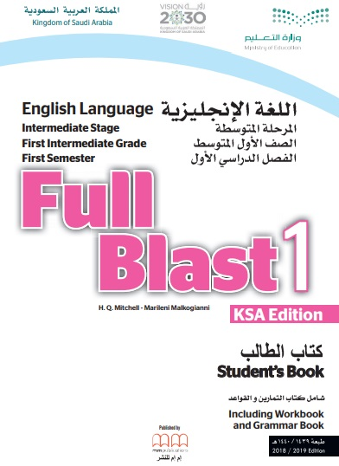

Full Blast3
1st Term Syllabus Distribution 1440^{H}/1441^{H} / 2nd Grade Intermediate

Weeks |  |  |  | Months
4th week | 3rd week | 2nd week | 1st week | Moharram
23/1 – 27/1 | 16/1 – 20/1 | 9/1 – 13/1 | 2/1 – 6/1 | Moharram
Module 1  1c+1d | Module 1  That’s Me  1a +1b | Hello | Back to School | Moharram
8th week | 7th week | 6th week | 5th week | Moharram  &  Safar
21/2 -25/2 | 14/2– 18/2 | 7/2– 11/2 | 30/1 – 4/2 | Moharram  &  Safar
Module 2  2e+Round-up | Module 2  2c+2d | Module 2  Exploring  2a +2b | Module 1  1e+Round-up | Moharram  &  Safar
12th week | 11th week | 10th week | 9th week | Safar  &  Rabei I
20/3 – 24/3 | 13/3 –17/3 | 6/3 – 10/3 | 28/2 – 3/3 | Safar  &  Rabei I
Module 4  Places  4a +4b | Module 3  3e+Round-up | Module 3  3c+3d | Module 3  Adventure  3a +3b | Safar  &  Rabei I
16th week | 15th week | 14th week | 13th week | Rabei I  &  Rabie II
18/4 – 22/4 | 11/4 –15/4 | 4/4 – 8/4 | 27/3 –1/4 | Rabei I  &  Rabie II
Oral Test | Revision | Module 4  4e+Round-up | Module 4  4c+4d | Rabei I  &  Rabie II
 |  | 18th week | 17th week | Rabie II  &  Jamad I
 |  | 3/5 –7/5 | 25/4 – 29/4 | Rabie II  &  Jamad I
 |  | Final Exam | Final Exam | Rabie II  &  Jamad I
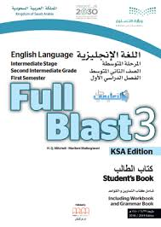

Full Blast5

1st Term Syllabus Distribution 1440^{H}/1441^{H} / 3rd Grade Intermediate

Weeks |  |  |  |  | Months
4th week | 3rd week | 2nd week | 1st week | Moharram
23/1 – 27/1 | 16/1 – 20/1 | 9/1 – 13/1 | 2/1 – 6/1
Module 1  1e+Round-up | Module 1  1c+1d | Module 1  Teen trends  1a +1b | Back to School
8th week | 7th week | 6th week | 5th week | Moharram &  Safar
21/2 -25/2 | 14/2– 18/2 | 7/2– 11/2 | 30/1 – 4/2
Module 3  Broaden your mind  3a +3b | Module 2  2e+Round-up | Module 2  2c+2d | Module 2  Standing out  2a +2b
12th week | 11th week | 10th week | 9th week | Safar  &  Rabei I
20/3 – 24/3 | 13/3 –17/3 | 6/3 – 10/3 | 28/2 – 3/3
Module 4  4c+4d | Module 4  Nature  4a +4b | Module 3  3e+Round-up | Module 3  3c+3d
16th week | 15th week | 14th week | 13th week | Rabei I  &  Rabie II
18/4 – 22/4 | 11/4 –15/4 | 4/4 – 8/4 | 27/3 – 1/4
Revision | Revision | Oral Test | Module 4  4e+Round-up
 |  | 18th week | 17th week | Rabie II  &  Jamad I
 |  | 3/5 – 7/5 | 25/4 –29/4
 |  | Final Exam | Final Exam
