1st Term Syllabus Distribution 1440^{H}/1441^{H} / 1st Grade Secondary
Traveller1

Weeks |  |  |  | Months
4th week | 3rd week | 2nd week | 1st week | Moharram
23/1 – 27/1 | 16/1 – 20/1 | 9/1 – 13/1 | 2/1 – 6/1 | Moharram
Module 1  1e+Round-up | Module 1  1c+1d | Module 1  Youth culture  1a +1b | Back to School | Moharram
8th week | 7th week | ^{6th} week | 5th week | Moharram  &  Safar
21/2 -25/2 | 14/2– 18/2 | 7/2– 11/2 | 30/1 – 4/2 | Moharram  &  Safar
Module 3  Going places  3a +3b | Module 2  2e+Round-up  1st period test | Module 2  2c+2d | Module 2  What an experience !  2a +2b | Moharram  &  Safar
12th week | 11th week | 10th week | 9th week | Safar  &  Rabei I
20/3 – 24/3 | 13/3 –17/3 | 6/3 – 10/3 | 28/2 – 3/3 | Safar  &  Rabei I
Module 4  4c+4d | Module 4  Nowadays  4a +4b | Module 3  3e+Round-up | Module 3  3c+3d | Safar  &  Rabei I
16th week | 15th week | 14th week | 13th week | Rabei I  &  Rabie II
18/4 – 22/4 | 11/4 –15/4 | 4/4 – 8/4 | 27/3 –1/4 | Rabei I  &  Rabie II
Oral Test | Revision | 2nd period test  Revision | Module 4  4e+Round-up | Rabei I  &  Rabie II
 |  | 18th week | 17th week | Rabie II  &  Jamad I
 |  | 3/5 –7/5 | 25/4 – 29/4 | Rabie II  &  Jamad I
 |  | Final Exam | Final Exam | Rabie II  &  Jamad I

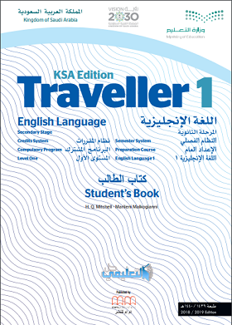

1st Term Syllabus Distribution 1440^{H}/1441^{H} / 2nd Grade Secondary
Traveller3
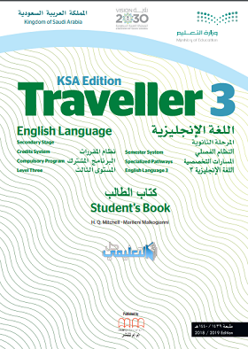

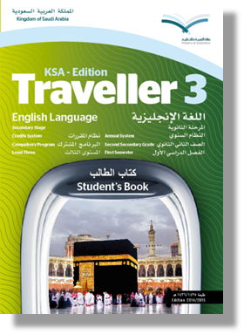
Weeks |  |  |  | Months
4th week | 3rd week | 2nd week | 1st week | Moharram
23/1 – 27/1 | 16/1 – 20/1 | 9/1 – 13/1 | 2/1 – 6/1 | Moharram
Module 1  listening& speaking  1 b ) writing  Round-up | Module 1  1a ) listening & speaking Writing  1 b ) reading/ Vocabulary / grammar | Module 1  Window on the world  1 a ) reading/ Vocabulary / grammar  1 a ) /listening & reading/ Vocabulary & grammar | Back to School | Moharram
8th week | 7th week | 6th week | 5th week | Moharram  &  Safar
21/2 -25/2 | 14/2– 18/2 | 7/2– 11/2 | 30/1 – 4/2 | Moharram  &  Safar
Module 3  Work & Leisure  3 a ) reading/ Vocabulary / grammar/ 3a ) /listening & reading/ Vocabulary & grammar | Module 2  2 b ) Vocabulary / grammar listening& speaking  2 b ) writing / Round-up  1st period test | Module 2  2a ) listening & speaking  Writing  2 b ) reading/ Vocabulary / grammar | Module 2  Heros  2 a ) reading/ Vocabulary / grammar  2a ) /listening & reading/ Vocabulary & grammar | Moharram  &  Safar
12th week | 11th week | 10th week | 9th week | Safar  &  Rabei I
20/3 – 24/3 | 13/3 –17/3 | 6/3 – 10/3 | 28/2 – 3/3 | Safar  &  Rabei I
Module 4  4a ) listening & speaking  Writing  4 b ) reading/ Vocabulary / grammar | Module 4  Planet Earth  4 a ) reading/ Vocabulary / grammar  4a ) /listening & reading/ Vocabulary & grammar | Module 3  3 b ) Vocabulary / grammar  listening & speaking  3 b ) writing / Round-up | Module 3  3a ) listening & speaking  Writing  3 b ) reading/ Vocabulary / grammar | Safar  &  Rabei I
16th week | 15th week | 14th week | 13th week | Rabei I  &  Rabie II
18/4 – 22/4 | 11/4 –15/4 | 4/4 – 8/4 | 27/3 –1/4 | Rabei I  &  Rabie II
Oral Test | Revision | Module 4  Round-up  2nd period test | Module 4  4 b ) Vocabulary / grammar  listening & speaking  4 b ) writing | Rabei I  &  Rabie II
 |  | 18th week | 17th week | Rabie II  &  Jamad I
 |  | 3/5 –7/5 | 25/4 – 29/4 | Rabie II  &  Jamad I
 |  | Final Exam | Final Exam | Rabie II  &  Jamad I
Traveller5

1st Term Syllabus Distribution 1440^{H}/1441^{H} / 3rd Grade Secondary
Weeks |  |  |  | Months
4th week | 3rd week | 2nd week | 1st week | Moharram
23/1 – 27/1 | 16/1 – 20/1 | 9/1 – 13/1 | 2/1 – 6/1 | Moharram
Module 1  Unit 2  The place to be  reading/ Vocabulary / grammar/ listening / Vocabulary / grammar | Module 1  Unit 1  Vocabulary / grammar Speaking/  examination Practice /Writing | Module 1  All over the world  Unit 1  On holiday  reading/ Vocabulary / grammar/ listening | Back to School | Moharram
8th week | 7th week | 6th week | 5th week | Moharram  &  Safar
21/2 -25/2 | 14/2– 18/2 | 7/2– 11/2 | 30/1 – 4/2 | Moharram  &  Safar
Module 2  Unit 4  Adventure  reading/ Vocabulary / grammar/ listening / Vocabulary / grammar | Module 2  Unit 3  Vocabulary / grammar Speaking/  examination Practice /Writing  1st period test | Module 2  Beyond the limits  Unit 3  Crime and punishment  reading/ Vocabulary / grammar/ listening | Module 1  Unit 2  Speaking /examination Practice /Writing  Round-up | Moharram  &  Safar
12th week | 11th week | 10th week | 9th week | Safar  &  Rabei I
20/3 – 24/3 | 13/3 –17/3 | 6/3 – 10/3 | 28/2 – 3/3 | Safar  &  Rabei I
Module 3  Unit 6  The environment  reading/ Vocabulary / grammar/ listening / Vocabulary / grammar | Module 3  Unit 5  Vocabulary / grammar Speaking/  examination Practice /Writing | Module 3  What the future holds  Unit 5  Life style  reading/ Vocabulary / grammar/ listening | Module 2  Unit 4  Speaking /examination Practice /Writing  Round-up | Safar  &  Rabei I
16th week | 15th week | 14th week | 13th week | Rabei I  &  Rabie II
18/4 – 22/4 | 11/4 –15/4 | 4/4 – 8/4 | 27/3 – 1/4 | Rabei I  &  Rabie II
Oral Test | Revision | 2nd period test  Revision | Module 3  Unit 6  Speaking /examination Practice /Writing  Round-up | Rabei I  &  Rabie II
 |  | 18th week | 17th week | Rabie II  &  Jamad I
 |  | 3/5 – 7/5 | 25/4 –29/4 | Rabie II  &  Jamad I
 |  | Final Exam | Final Exam | Rabie II  &  Jamad I
